Table of Contents

1 Introduction 1

1.1 Intended Audience 1

1.2 Purpose 1

1.3 Privacy and Security 1

1.4 Key Contacts 1

2 System Overview 2

2.1 System Architecture Diagram 2

3 Implementation 3

3.1 Workflow Diagram 3

3.2 Electronic Health Record Integration Requirements 3

4 System Use 4

4.1 User Access Considerations 4

4.2 User Authentication Considerations 4

4.3 Accessing the System 4

4.3.1 MyPAIN 4

4.3.2 PainManager 5

4.4 System Organization and Navigation 5

4.4.1 MyPAIN Navigation 6

4.4.2 PainManager Navigation 9

4.5 Exiting the System **Error! Bookmark not defined.**

4.5.1 Exiting MyPAIN 12

4.5.2 Exiting PainManager 12

5 Troubleshooting and Support 12

5.1 Error Messages 13

5.2 Support 13

Appendix A: Record of Changes 14

Appendix B: Acronyms 15

Appendix C: Glossary 16

Appendix D: Referenced Documents 18

Appendix E: Approvals 19

# Introduction

This Operations Manual (OM) documents components of the Clinical Decision Support for Chronic Pain Management (CDS4CPM) system for [SITE NAME] and documents decisions made at the local level to finalize the integration of the standards-based application.

The following icons are intended to assist readers to find relevant information for each clinical decision support (CDS) artifact:

|  |  |
| --- | --- |
| MyPAIN and PainManager logos | MyPAIN: The patient-facing CDS artifact |
| MyPAIN and PainManager logos | PainManager: The provider-facing CDS artifact |

## Intended Audience

This document is intended for clinical leaders, project managers, informaticians and information technology managers.

## Purpose

This OM is intended to outline project information and outline the tools necessary for informatics and technical staff, clinical leaders and administrators to successfully manage and navigate the CDS4CPM system. This document is intended to assist with onboarding new individuals to the project. This document is designed to be updated as the CDS4CPM artifacts are finalized and their support processes are finalized. The changes will be logged in ***Table A-1*** in the Appendix.

## Privacy and Security

All required privacy and security steps were taken to develop and implement this solution in the local [SITE NAME] environment. For any questions about this, please see the key contact list included in Section 1.4. This document should not be shared without the approval from the Co-PI, [CO-PI NAME].

## Key Contacts

|  |  |  |
| --- | --- | --- |
| **Name** | **Role** | **Email** |
|  | Co-PI |  |
|  | Co-PI |  |
|  | Project Manager |  |
|  | Technical Lead |  |
|  | [EHR Patient Portal] Integration Lead |  |
|  | FHIR Integration Lead |  |
|  | Security Liaison |  |

# System Overview

Overall CDS4CPM System Diagram

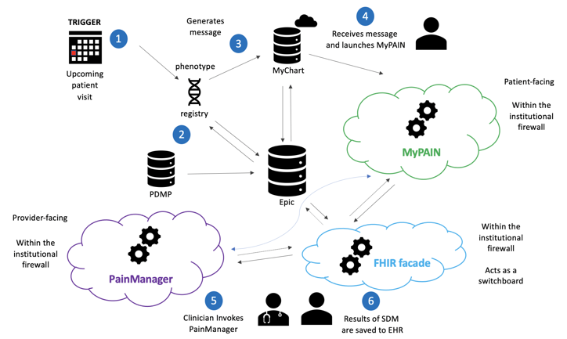

The CDS4CPM system is designed to identify patient visits within the forthcoming 30 days for which patients have one or more of the following conditions: chronic low back pain, osteoarthritis of the hip, osteoarthritis of the knee, and/or fibromyalgia; and exclude patients who are younger than age 18, have cancer-related chronic pain, and are receiving palliative care.

Once patients are identified, the system generates a message that is sent to the patient via [Site Name’s] [EHR Patient Portal]. This message invites the patient to use the MyPAIN tool. Once submitted, patient responses are written into the patient’s record in Epic.

Providers are notified via a conditional banner that a patient with an upcoming appointment meets the inclusion criteria. The provider may open PainManager and examine patient responses that were submitted via MyPAIN. Furthermore, providers may review other relevant patient information from Epic within the tool. When the provider and patient meet, they can use the information gathered within MyPAIN and PainManager to facilitate shared decision making (SDM). The results of this SDM are saved within Epic.

## System Architecture Diagram

***Figure 1*** depicts the instantiated system inside the [SITE NAME] institutional environment.

Figure 1. [SITE NAME] System Architecture Diagram (MyPAIN, FHIR Façade/Switchboard, and PainManager)

[INSERT EXTERNAL, INTERFACE AND INTERNAL NETWORK DIAGRAM SHOWING RELATIONSHIPS, EXTERNAL AND PROVIDER DATA FLOW AND SECURITY DETAILS FOR [SITE NAME]

# Implementation

This section details implementation considerations and documentation.

## Workflow Diagram

***Figure 2*** is a flow diagram describing the workflow for the MyPAIN and PainManager applications.

Figure 2. Flow Diagram for [SITE NAME]

[INSERT MYPAIN AND PAINMANAGER FLOW DIAGRAM AS IMPLEMENTED AND INTEGRATED INTO VENDOR SYSTEM FOR [SITENAME]

## Electronic Health Record Integration Requirements

Provide the details of the requirements to integrate the MyPAIN and PainManager applications within the electronic health record system (Epic). Documents referenced below are accessible via an internal repository (e.g., Box).

* Reference the full [IG](https://ig-develop.rti.alphora.com/index.html) for the artifacts (restricted access, >10 online pages)
* Include the [“Hello World” IG](https://github.com/DBCG/cds4cpm/blob/master/input/pagecontent/implementation.md) (restricted access, <5 online pages)
* Include a table of the necessary [data elements](https://ig-develop.rti.alphora.com/data-elements.html) and their details (restricted access, 2 online pages)
* Access the FHIR façade [read-me file](https://app.box.com/file/697252105953) (restricted access, 2 online pages)
* [INCLUDE ANY mapping resources, application programming interface connector pieces, log files, ETC. FOR [SITE NAME]]

# System Use

The following subsections provide an overview of the system’s features, user interface, and navigation.

## User Access Considerations

User access to MyPAIN is dependent upon being selected for inclusion in the registry. User access to PainManager is dependent upon selection for participation in the pilot.

## User Authentication Considerations

User access to MyPAIN and PainManager are handled via OAuth 2.0 because both are SMART on FHIR applications.

## Accessing the System

### The steps below outline how users access each component of the system at [SITE NAME].



## MyPAIN

* Upon being invited to participate in an SDM session during a visit with their provider, the eligible patient with chronic pain will receive an invitation message in their [EHR PATIENT PORTAL] inbox. [SEE DETAILS IN FIGURES TO FOLLOW FOR [SITE NAME]
* The patient will click on the following link [SEE DETAILS IN FIGURES TO FOLLOW FOR [SITE NAME] to launch MyPAIN. The questionnaire will launch within the [EHR Patient Portal] window inside the patient’s browser. [SEE DETAILS IN FIGURES TO FOLLOW FOR [SITE NAME]
* When a patient enters information into MyPAIN (SEE THE MYPAIN CLINIC TIP SHEET TEMPLATE), those data will be available to a provider in PainManager.

|  |  |
| --- | --- |
| Figure 3. MyPAIN Invitation | Figure 4. MyPAIN Upon Launch |
| [PROVIDE A [SITE NAME] EXAMPLE OF THIS] |  |

The patient will navigate sequentially through the app by clicking the “next” button at the bottom of the screen. At the top right, a circle will indicate progress through MyPAIN. There is a back button at the top left of each screen. [BE SURE TO INLUDE ANY ADDITIONAL DETAILS SUCH AS USE OF BROWSER BACK BUTTON, ETC. FOR [SITE NAME].



## PainManager

* Providers who are enrolled in the pilot will have a persistent link (SEE THE PAINMANAGER CLINIC TIP SHEET TEMPLATE) they can use to access PainManager from Epic Hyperspace
* When a patient enters information into MyPAIN (SEE THE MYPAIN CLINIC TIP SHEET TEMPLATE), those data will be available to a provider in PainManager.
* Other ways to access PainManager include (SEE THE PAINMANAGER CLINIC TIP SHEET TEMPLATE).

## System Organization and Navigation

This section details how MyPAIN and PainManager are organized and how users navigate the system.



## MyPAIN Navigation

The steps for navigating MyPAIN are outlined below and further detailed in the MyPAIN Clinic Tip Sheet (SEE THE PAINMANAGER CLINIC TIP SHEET TEMPLATE).

#### Steps for Using MyPAIN

* The patient accesses MyPAIN via [EHR Patient Portal].
* The patient responds to MyPAIN questions about:
  + pain location,
  + pain intensity,
  + pain interference,
  + treatments (basic, mind–body, new, nontraditional, nonprescription, and prescription), and
  + treatment goals and barriers.
* The patient has the option to view the two educational resources provided to prepare for their upcoming visit with their provider.
* The patient indicates whether the use of MyPAIN helped them prepare for their visit and to submit their final responses.
* MyPAIN provides the patient’s responses to their provider to review before or during their visit.
* The provider and patient review these responses together to develop a treatment plan during an SDM encounter in a clinic visit.

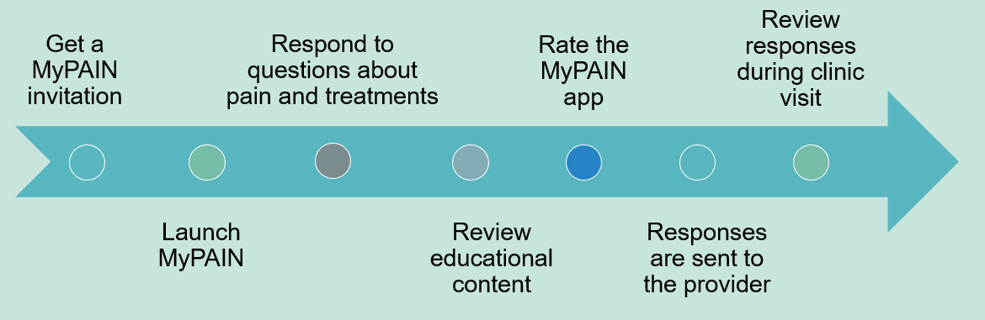

#### How Patients Navigate MyPAIN MyPain logo

* The patient will navigate sequentially through the app by clicking the “next” button at the bottom of the screen. At the top right, a circle will indicate progress through MyPAIN. There is a back button at the top left of each screen. [SEE DETAILS IN FIGURES TO FOLLOW FOR [SITE NAME]
* The patient will answer questions about their pain and treatment preferences (no responses are required).
  + Provide the following instructions to the patient: (NOTE: Example screens are included in ***Figures 10–12.***)
    - Indicate **where you have been experiencing pain in the last 7 days and the type of pain** by clicking the button response options.
    - Indicate **your pain intensity overall for the past 7 days** by clicking the button response options.
    - Indicate **your pain interference overall for the past 7 days** by clicking the button response options.

|  |  |  |
| --- | --- | --- |
| Figure 10. | Figure 11. | Figure 12. |
|  |  |  |

* + Indicate **treatments you have tried and how they worked**. These are clickable button response options. (NOTE: Example screens are included in ***Figures 13–18.)***

|  |  |  |
| --- | --- | --- |
| Figure 13. | Figure 14. | Figure 15 |
|  |  |  |
| Figure 16. | Figure 17. | Figure 18. |
|  |  |  |

* + Indicate **your activity goals and barriers**. These are open textbox response options with no set character limit. (NOTE: Example screens are included in ***Figures 19–20.***)

|  |  |
| --- | --- |
| Figure 19. | Figure 20. |
|  |  |

## PainManager Navigation

|  |
| --- |
| PainManager logo |

There are four core sections or tabs in PainManager:

* Pertinent Conditions
* Current Pertinent Treatments
* Shared Decision Making
* Urine Drug Screening

Each of these is outlined below and example screens are included in ***Figures 21–25.***

* If the patient has entered data for any items in MyPAIN, the data are displayed in the “Shared Decision Making (patient-provided data)” tab of PainManager (see the following screenshots). That tab is set to open by default whenever MyPAIN data are available. PainManager will display the date when the patient submitted the data; the patient’s activity goals and barriers; and the patient’s reported pain locations, pain intensity, and pain interference in the last 7 days.

Figure 21

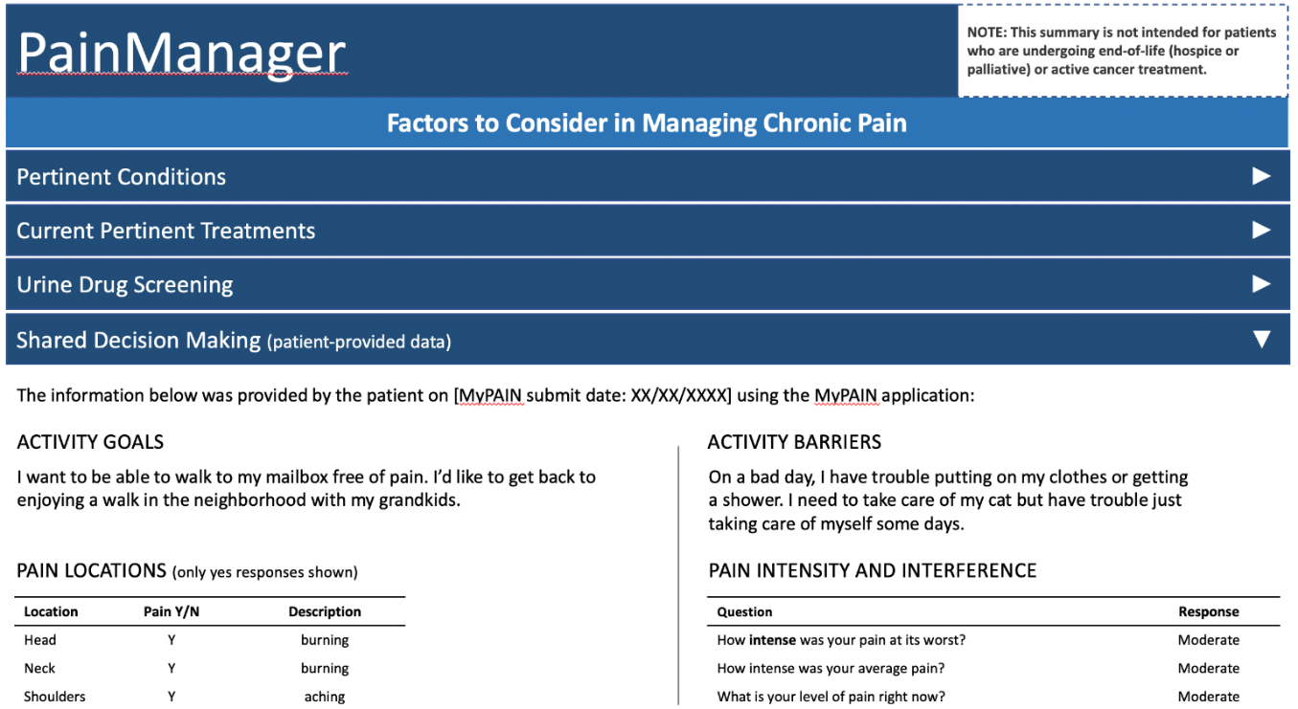

* The Pertinent Conditions section contains data on chronic pain conditions and on co-morbid conditions increasing risk when using opioids. Lookback is 12 months unless otherwise specified.

Figure 22

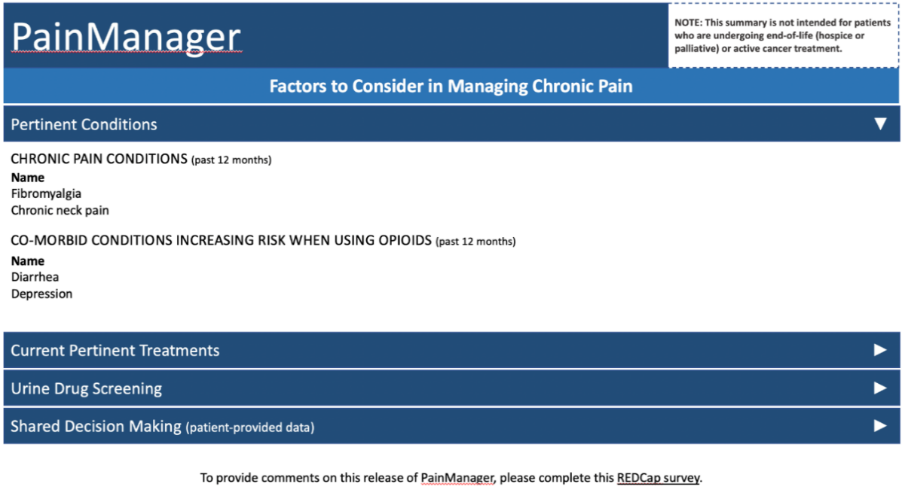

* The Current Pertinent Treatments tab contains data on active prescriptions including non-opioids and opioids, the date prescribed, and the sig. This section also includes a calculated morphine milligram equivalent (MME)/day at the individual prescription level and across all relevant opioid prescriptions. (Calculations should align with Epic’s morphine equivalent daily dose value; see the Embedded MME/Day Calculator slides for more details.) Finally, patient-reported data from MyPAIN on treatments and their effectiveness are included as well.

Figure 23

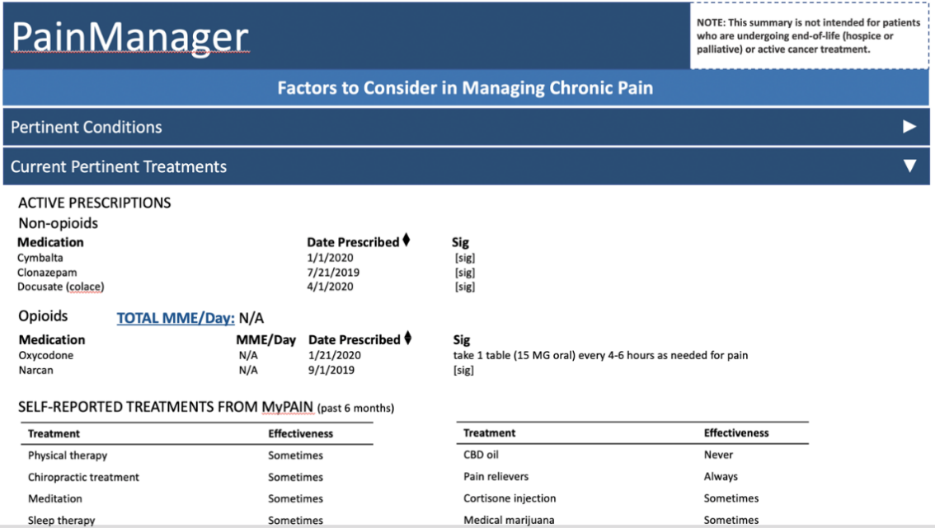

* In the Urine Drug Screening section, a table with relevant results is provided. Details on the test, the test date, and the result are provided by most recent test farthest to the left.

Figure 24

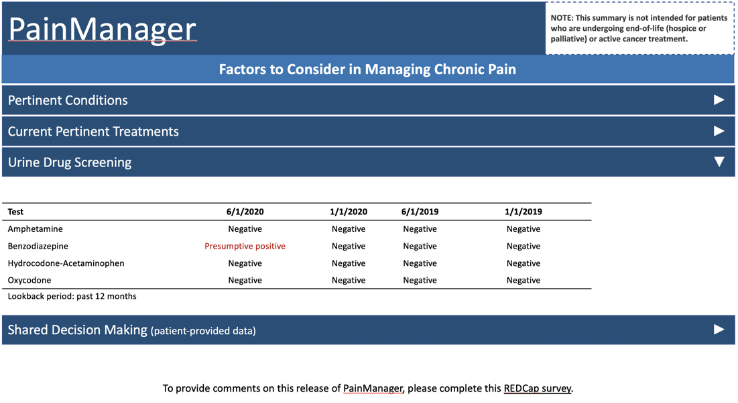

* These data are intended to support SDM between the patient and the provider during an encounter to develop a chronic pain management plan that better incorporates patient goals and values. Results of the encounter should be stored in the patient chart using an [EHR-specific phrase or similar] (further details are provided in the [PainManager Tip Sheet].
* To support the pilot and gain feedback on the use of MyPAIN and PainManager, use this link [please note the link to the user feedback survey in the footer of PainManager]. Clinicians can submit their comments and/or requests for changes, fixes, or enhancements using this survey.

Figure 25

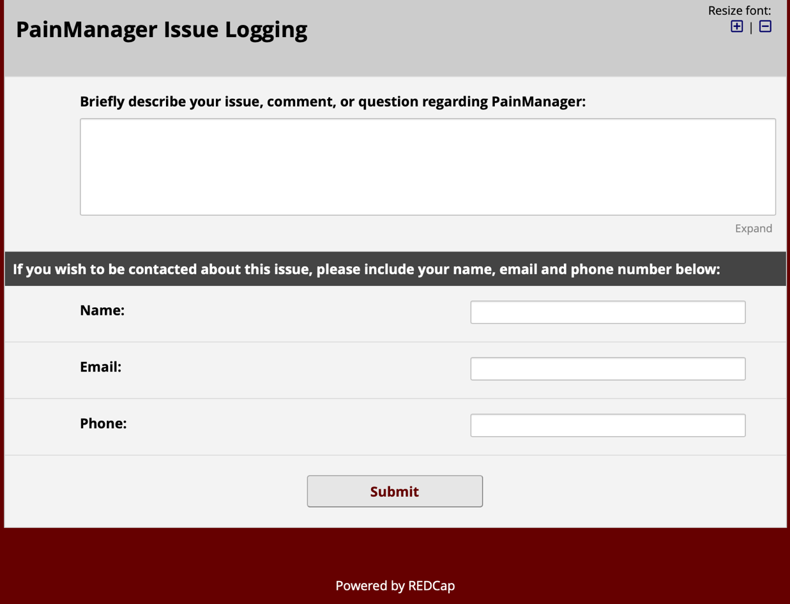

## Exiting MyPAIN

Once a patient has navigated through MyPAIN and entered the applicable information, the patient should submit their responses. Once the patient confirms that the responses have been submitted, the patient may log out of [EHR Patient Portal] and close their browser window. c

## Exiting PainManager

Once a provider has reviewed patient information within PainManager, the provider should press submit to save any notes that may have been entered. Once the provider has confirmed that the information has been submitted, the provider can exit PainManager. [SITE NAME examples to be included below]

# Troubleshooting and Support

The Help Desk maintains a resource [SITE NAME location to be included] that references this OM for providing support for MyPAIN and PainManager.

## Error Messages

Currently, the only error message that appears within the two applications is a message in PainManager related to meeting the inclusion criteria. [SITE NAME examples to be included below]

## Support

Most technical support issues related to the soft go-live of MyPAIN and PainManager should be addressed within [SITE NAME survey tool]. Providers participating in the CDS4CPM soft go-live and pilot may directly contact the site co-PIs with any major concerns (e.g., a safety issues) as listed in the introductory material. CDS4CPM technical support staff can access the project Jira tracking tool to create bugs and add them to the fix workflow.

In the future, these requests may be directed to the service desk.

Appendix A: Record of Changes

Table A-1. Record of Changes

| Version Number | Date | Author/Owner | Description of Change |
| --- | --- | --- | --- |
|  |  |  |  |
|  |  |  |  |

Appendix B: Acronyms

Table B-1. Acronyms

| Acronym | Literal Translation |
| --- | --- |
| ACPA | American Chronic Pain Association |
| AHRQ | Agency for Healthcare Research and Quality |
| API | application programming interface |
| CAT | computerized adaptive testing |
| CDC | Centers for Disease Control and Prevention |
| CDS | clinical decision support |
| CNCP | chronic noncancer pain |
| CQL | Clinical Quality Language |
| EHR | electronic health record |
| FHIR | Fast Healthcare Interoperability Resources |
| HL7 | Health Level Seven |
| IRB | institutional review board |
| IT | information technology |
| MEDD | maximum equivalent daily dose (see details on the Epic-specific calculation) |
| MME/day | morphine milligram equivalent per day (see CDC guideline) |
| MVP | minimum viable product |
| MyPAIN | My Pain Assessment and Information Needs |
| NLM VSAC | National Library of Medicine Value Set Authority Center |
| PCCDS-LN | Patient-Centered Clinical Decision Support Learning Network |
| PDMP | prescription drug monitoring program |
| PEG Scale | pain, enjoyment, and general activity scale for pain |
| PMD | Pain Management Dashboard |
| PRO | patient-reported outcome |
| PROMIS | Patient-Reported Outcomes Measurement Information System |
| SDD | system design document |
| SDM | shared decision making |
| SDOH | social determinants of health |
| SHARE | seek, help, assess, reach, and evaluate |
| SMART | Substitutable Medical Applications, Reusable Technology |
| UI | user interface |

Appendix C: Glossary

Table C-1. Glossary

| Term | Definition |
| --- | --- |
| application (app) | a program or group of programs designed for end users; typically, software that a user downloads, installs, and manages |
| batch testing | synonymous with unit testing (see below) |
| beta testing | the release of a preliminary version of a software system to a limited set of users to obtain feedback |
| code | items that comprise a component |
| component | elements of an individual container |
| container | high-level building blocks of the software system in scope |
| context | the software system in scope |
| edge case | a rare use case scenario that would typically occur only under extreme conditions, intended to test the limits of a system |
| feature | a set of related requirements that allows the user to satisfy a business objective or need |
| FHIR façade | an architectural pattern for implementing capability in a standards-compliant way, in the absence of that support from existing/installed vendor systems |
| function | a specification of behavior between outputs and inputs |
| HAPI FHIR | a complete implementation of the HL7 FHIR standard for health care interoperability in Java intended to provide a flexible way of adding FHIR capability to applications |
| “Hello World” | a test confirming that the basic, established framework of an application or system is sufficient for continued development |
| interface requirement | a system requirement that involves an interaction with another system |
| logic testing | a process by which the clinical decision support logic is evaluated systematically |
| minimum viable product (MVP) | those features or functions of a system which, when built out, represent a core version of a functioning system |
| patient population testing | a method of testing a software system using a synthetic set of patient population data to verify that the system behaves as expected |
| requirement | a condition or capability needed by a user to solve a problem or achieve an objective |
| Section 508 compliance testing | testing of a document, application, or system to verify compliance with the standards within Section 508 of the Rehabilitation Act of 1973 |
| service | centrally managed software that provides some logic or functionality to end users, which a user accesses (via application programming interface, website, etc.) |
| shareability | the extent to which the resulting CDS4CPM artifacts and implementation guides for each artifact can be posted to a publicly accessible repository so that those artifacts can be implemented by a variety of care providers or clinics in different geographic settings |
| site-specific adapter | an instance of a FHIR façade at a site, implemented with proprietary mechanisms, but exposed using standard FHIR application programming interfaces |
| smoke testing | preliminary testing of important system functions to reveal simple failures that would prevent a prospective software release |
| software as a service (SaaS) | a method of software delivery and licensing in which software is accessed online via a subscription rather than bought and installed on individual computers |
| [software] system | a series of components working together to deliver services |
| sprint | in agile development, a designated period during which a selected set of tasks is expected to be completed |
| Synthea | an open-source, synthetic patient generator that models the medical history of synthetic patients |
| unit testing | the testing of individual components or containers to confirm that they are fit for use in a larger system |
| user acceptance testing | a testing process designed to confirm that a software system functions as expected for its intended user base |
| user interface (UI) | the rules of engagement for a user interacting with a specific page on a website or screen within an application |
| version | a unique state of computer software |

Appendix D: Referenced Documents

Table D-1. Referenced Documents

Full references to linked documents detailed in the above are included below.

| Document Name | Document Location and/or URL | Issuance Date |
| --- | --- | --- |
|  |  |  |
|  |  |  |
|  |  |  |

Appendix E: Approvals

The undersigned acknowledge that they have reviewed the OM and agree with the information presented within this document. Changes to this OM will be coordinated with, and approved by, the undersigned, or their designated representatives.

Table E-1. Approvals

| Document Approved By | Date Approved |
| --- | --- |
| [Name of Project Director], Project Director | [DATE] |
| [Name of Project Champion], Project Champion | [DATE] |